Directions: The goal of the following problems is to help challenge and deepen your understanding of the current topic. Don’t assume that you will know how to answer each and every question. You will work with at least two other students in the class to try and find solutions and write arguments for each of the following questions. Be sure that you question your classmates’ reasoning. If you don’t understand how they are getting something you should ASK THEM TO EXPLAIN! Being able to defend your reasoning is important and so you are actually helping them by asking them to explain.

Challenge Questions
- A farmer is going to use fence to make a pen shaped like cutting a circle in half and inserting a rectangle (like in the picture below). If the pen is to have an area of , how should he make the pen to minimize the amount of fence needed? Find all dimensions of the pen and sketch a picture of it.

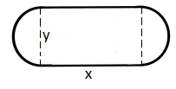
We begin by labeling the diagram as follows.

We can therefore calculate the total amount of fencing used as
We know that the area of the pen is given by . Since the pen needs to have an area of this means that .
With this information we can state that
We then calculate
We see that
when
is undefined when

We put these values on a number line to determine where T has a minimum.

$$-$$
$$+$$
$$MIN$$

Note that we aren’t consider with values below 0 since these are not possible radius lengths.

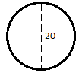
So, we have that if then the total amount of fencing used would minimized.
This implies that which means that the pen would ultimately be in the shape of a circle.

- For each , a triangle is formed with vertices and where is the function given below. What is the value of x which results in the triangle of largest area? What is this largest area?

We start by drawing a picture of the scenario.
We want to maximize the area of a triangle so we calculate that the area of a triangle here would be given by:

We then calculate

We see that
when
is never undefined since for any value of x (Note ).

$$-$$
$$+$$
$$-$$
$$MIN$$
$$MAX$$

Remember that we are only looking at values of , so we can conclude that the absolute maximum of the area of the triangle would occur at .

The area of this triangle would be

- A rectangular box, without a top, is to be made by cutting squares out of corners of a sheet of carboard and folding up the sides (like in the diagram below). Find the maximum volume of such a box from a sheet measuring 4 meters by 4 meters.

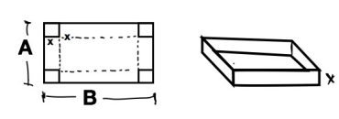
We see that the dimensions of the box are , and .
This implies that the volume of the box is given by

Therefore,
Clearly is never undefined.
when .

$$+$$
$$-$$
$$MAX$$

So, there is a maximum volume when .
Therefore, the maximum value of the box is


- A rectangular box, without a top, is to be made by cutting squares out of corners of a sheet of carboard and folding up the sides (like in the diagram below). Show that the maximum volume of such a box from a sheet measuring A meters by B meters occurs when the squares cut out have side lengths

As shown in the diagram we will assume that
We see that the dimensions of the box are , and .
This implies that the volume of the box is given by

Therefore,
Clearly is never undefined.
when
By the Quadratic Formula this occurs when
Notice there are two different values of x here:
(Note these values only exist if )
We put these values on a number We put these values on a number line and check for where there are maxes and mins.

$$+$$
$$-$$
$$MAX$$

Note that is between and . At this value we see that
Based on our previous findings we can assuming that this value is negative.

Also note that is less than . At this value we see that
Since this value must also be positive.

Note that the maximum value that x can be is . However, at this value the width of the box will equal 0 and so we can determine that even if the volume function increases after it can only increase to a value of 0 at best.

This shows that there must be a maximum value at

- A cone-shaped drinking cup is made from a cicular piece of paper of radius R by cutting out a sector and joining the edges of CA and CB. Find the angle that is needed in order to maximize the capacity of such a cup.
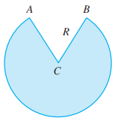
We want to maximize the volume of the resulting cone.
Therefore we want to use the equation .

Based on the picture of the resulting cone we can see that and therefore, .

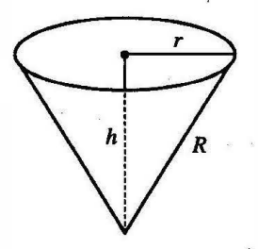
So we have that .
Note here that is a constant and so the volume equation here is completely in terms of the variable h.

We calculate that .
when
$$+$$
$$-$$

(we tested the values of )

So we have a maximum volume when and .

Now we turn to find the angle of .
We see from the first picture that the arc between A and B (over ) is given by .
Also, the circumference of the existing part of the blue circle above must be equal to the circumference of the circular base of the resulting cone. From this we can say that
We then substitute the value of r that we have for when the maximum volume occurs and we find that

